Lathe | 1
tool use

Lathe
A lathe is a machine that rotates the piece on the axis in order to perform various operations like cutting, facing, knurling, deformation and more. Metal spinning, thermal spraying, woodturning and metalworking are the common operations performed with a lathe machine.
http://www.engineeringarticles.org/lathe-lathe-operations-types-and-cutting-tools/

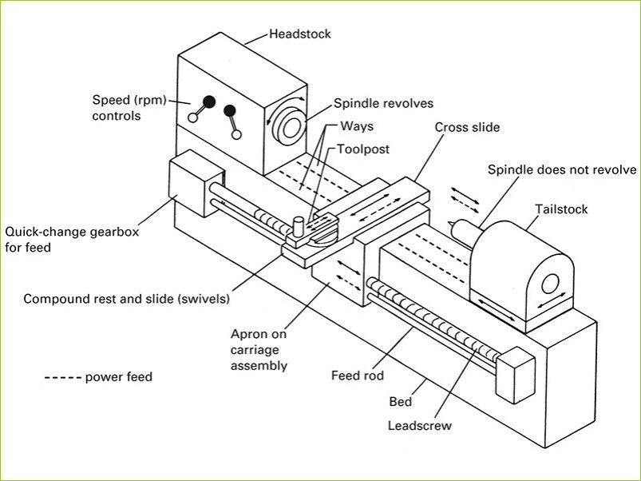
Requirements:

Proper eye protection must be worn—operate only with instructor’s permission and after
proper instructions have been received.

1. Beware of sharp-pointed metal edges when cutting metal discs to size and when
getting them ready for spinning.
2. Make sure that the tool rest base, tool rest, and fulcrum pin are securely tightened in
place before attempting to spin.
3. Never stand in line with the disc during a centering operation.
4. Make certain the spinning tools are fitted solidly to the handle.
5. Do not touch a spinning disc by hand.
6. Use the correct tool for the operation and slowly force material to match the forming
chuck.
7. Remove tool rest and pin when using steel wool or polishing.
8. Seek instructor’s help, if in doubt about a specific operation.

Different tools require different speeds, feeds and general use. See instructor before doing any operation.
