Dvorak iron worker model 314 | 4
Metals

Resources
- Scotchmans Industries Operators Manual

The Scotchman Ironworker is a versatile, multi-purpose, shearing, punching and forming machine engineered for trouble free operation.
The hydraulic system operates at 1,200 PSI and is protected from overload by a pilot operated relief valve.
Maintenance
Lubrication
Before operating the 314 apply oil to the shear bar blades, angle shear and the punch and die as well as to every 10-15 cuts.
Apply oil to the 4 pins two on the punch and two on the angle shear.
Twice per Week
- Grease the two bar shear beam zerks, one on each end for pins.
- Grease the two punch zerks, one in the pivot pin and one for the punch barrel.
- Grease the two angle shear zerks, one in the pivot pin an done for the top blade holder.
- Apply grease to the surface of the beam guide wear plates on the outer end of the main beam
Once per Month
- Oil the four clevis pins on the punch and angle shear
- Check the hydraulic oil level on the dipstick in the reservoir
Once per Year
- Change the hydraulic oil
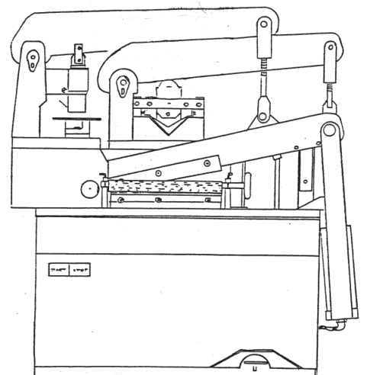
Machine Operation
Punch capacities
Thickness of Steel Diameter of punch
¼” 1-1/4”
5/16” 1-1/8”
3/8” 1”
½” 7/8”
Punch Operation
- Do not punch material thicker than the diameter of the punch
- Punch full, complete holes. Do not punch partial holes or past the edge of the material.
- Maintain sufficient material between the punched hole and the edge of the workpiece.
- Do not work with dull or damaged tooling
- Remove the clevis pin when using other stations
- The angle shear may be removed to provide a larger work area.

Angle Shear Operation
- Lubricate the blades
- Stay within the rated capacities
- The stroke may be shortened for small angles
- The angle shear can be used for mitering
- Unequal leg angle iron requires special blades
- Do not work with dull or damaged blades or allow excessive gap between the blades
- Remove the clevis pin when using other stations
Bar Shear Operation
- Lubricate the blades
- Less distortion at outer ends of the blades
- Rounds and squares may be cut on the bar shear
- Maintain proper blade clearance
- Hard material may damage blade
- Keep Cut-off area clear

Bar Shear capacities
Thickness of steel Length of cut
½” 4”
3/8” 6”
¼” 8”

