Weld joint types | 3
Metals

Resources
- Mechanicalengineering.com

There are five different types of welded joints for bringing two parts together for joining.
Five types of welded joints are butt joint, corner joint, lap joint, tee-joint and edge joint

1. Butt joint:
In Butt welded type, the parts lie in the same plane and are joined at their edges.

2. Corner joint:
The parts in a corner joint form a right angle and are joined at the center of the angle.

3. Lap joint:
Lap joint consists of two overlapping parts.

4. Tee-joint:
In a Tee-joint, one joint is the right angle to the other joint in the approximate shape of the letter “T”.

5. Edge joint:
The parts in edge joint are parallel with at least one of their edges in common and the joint is made at the common edge(s)

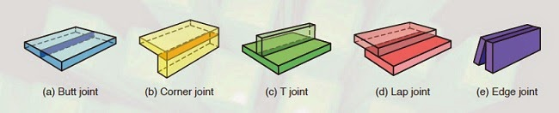

A cruciform joint is a specific joint in which four spaces are created by the welding of three plates of metal at right angles. Cruciform joints suffer fatigue when subjected to continuously varying loads.^{[6]}
In the American Bureau of Shipping Rules for Steel Vessels, cruciform joints may be considered a double barrier if the two substances requiring a double barrier are in opposite corners diagonally. Double barriers are often required to separate oil and seawater, chemicals and potable water, etc.^{[7]}
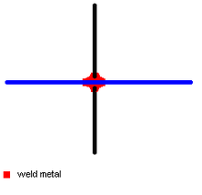
Diagram of a cruciform joint between 3 plates of metal

